# CS 340 README Template

## About the Project/Project Title

*This project is a CRUD application for managing animal shelter records, connecting to a MongoDB database to store and retrieve animal data for better organization and tracking.*

## Motivation

*This project serves as a hand-on example of CRUD operations in Python using MongoDB. The goal is to make tracking animals in shelters easier by being able to create, read, update, and delete information with a straightforward database management system.*

## Getting Started

*Steps to getting started:*

* *Import aac_shelter_outcomes.csv into the database.*
* *Create a simple index to query performance and a compound index to query data.*
* *Create a user in the MongoDB admin database that will have access to read and write.*
* *Configure the connection details in the Python script*
* *Run the script to start managing animal shelter records.*

## Installation

*Tools you’ll need:*

* *MongoDB to access the database.*
* *Python to run the .py & .ipynb files.*

## Usage

*Use this space to show useful examples of how your project works and how it can be used. Be sure to include examples of your code, tests, and screenshots.*

### Code Example

Logo & Unique Identifier

Working Radio Buttons:

Working Filters:

Interactive Data Table:

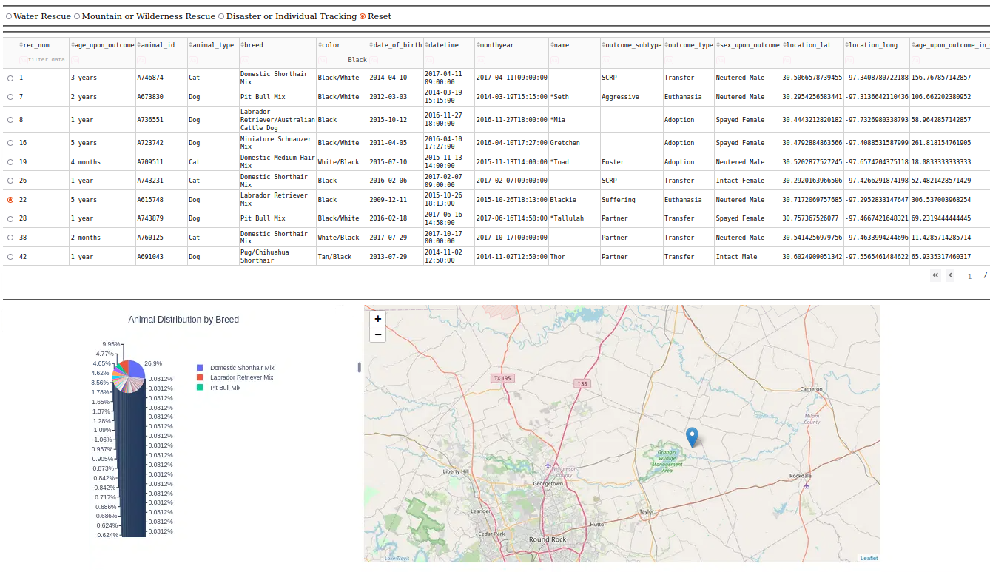

Chart:

Testing the system:

*An error I encountered was KeyError: "['_id'] not found in axis". In order to fix the issue, I changed the code to reflect the following: if '_id' in df.columns: df.drop(columns=['_id'], inplace=True).*

## Contact

Karina Aronov